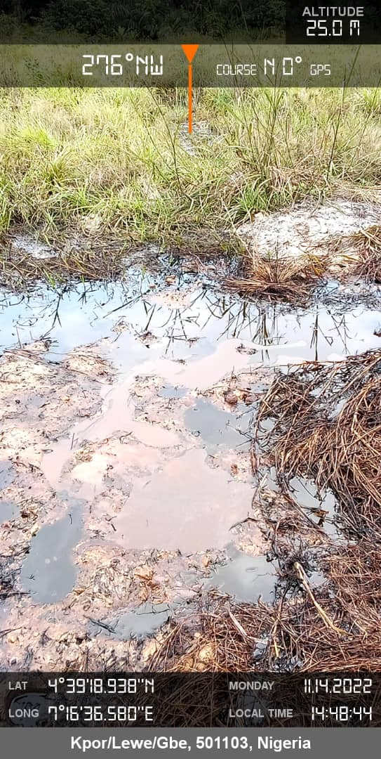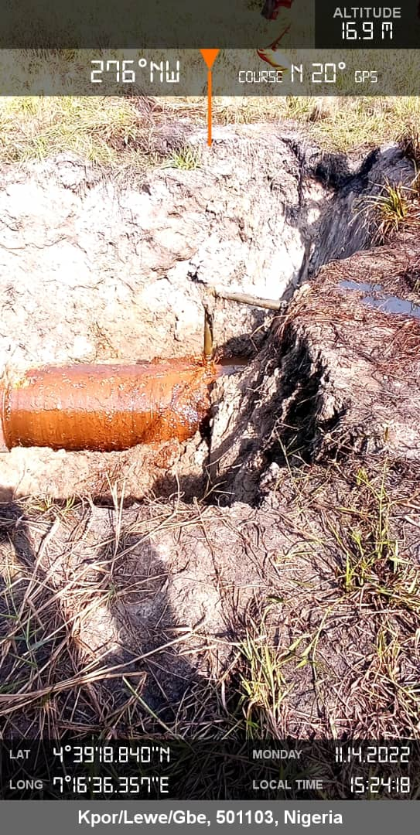
Figure 1. Pool of Crude oil and Impacted Area Fig.2. Arrow showing spill point

